CHAPTER FIVE

IMPLEMENTATION AND TESTING
This chapter presents a comprehensive account of the implementation and testing phases of the EyeCare Management System. The chapter begins by describing the implementation environment, including the hardware, software, and development tools used throughout the project. It then provides an overview of the coding approach and the major system modules developed. The testing strategy is subsequently defined, followed by a detailed presentation of test cases and their results. The chapter concludes with a discussion of the validation and verification activities conducted to confirm that the system meets its specified requirements.

5.1 Implementation Environment
The EyeCare Management System was implemented within a carefully selected development environment designed to support the full-stack, web-based architecture described in earlier chapters. The choice of tools and technologies was guided by the requirements for reliability, modern framework support, and suitability for deployment in resource-constrained clinical settings.
5.1.1 Hardware Environment
Development was carried out on a standard laptop computer running a 64-bit operating system with a minimum of 8 GB of RAM and 256 GB of storage. No specialized hardware was required for development or local testing. The system is designed to run on standard clinic workstations and is accessible via any modern web browser, eliminating the need for dedicated client hardware installations at point-of-use locations.

5.1.2 Software and Development Tools
The following software tools and technologies were used in the implementation of the EyeCare Management System:

Category | Tool / Technology | Purpose
Frontend Framework | Next.js 15 | Server-side rendering and client-side routing
Styling | Tailwind CSS | Responsive UI design and component styling
Backend Runtime | Node.js with Express.js | RESTful API development and server-side logic
Database | PostgreSQL | Relational data storage for all system entities
ORM | Prisma ORM | Type-safe database schema management and querying
Language | TypeScript | Strongly typed development across frontend and backend
Version Control | Git / GitHub | Source code management and collaborative versioning
Code Editor | Visual Studio Code | Primary development environment with TypeScript support
API Testing | Postman | Manual testing and verification of API endpoints
Package Manager | npm | Dependency management for Node.js packages
Table 5.1: Implementation Tools and Technologies
5.1.3 Development Architecture Overview
The system follows a three-tier web application architecture comprising a presentation layer implemented in Next.js 15 with Tailwind CSS, an application logic layer implemented in Node.js and Express.js, and a data layer managed by PostgreSQL through the Prisma ORM. Communication between the frontend and backend is handled through RESTful API endpoints secured with role-based authentication middleware. The Prisma schema defines all database entities, relationships, and constraints, ensuring data integrity across all modules of the system.
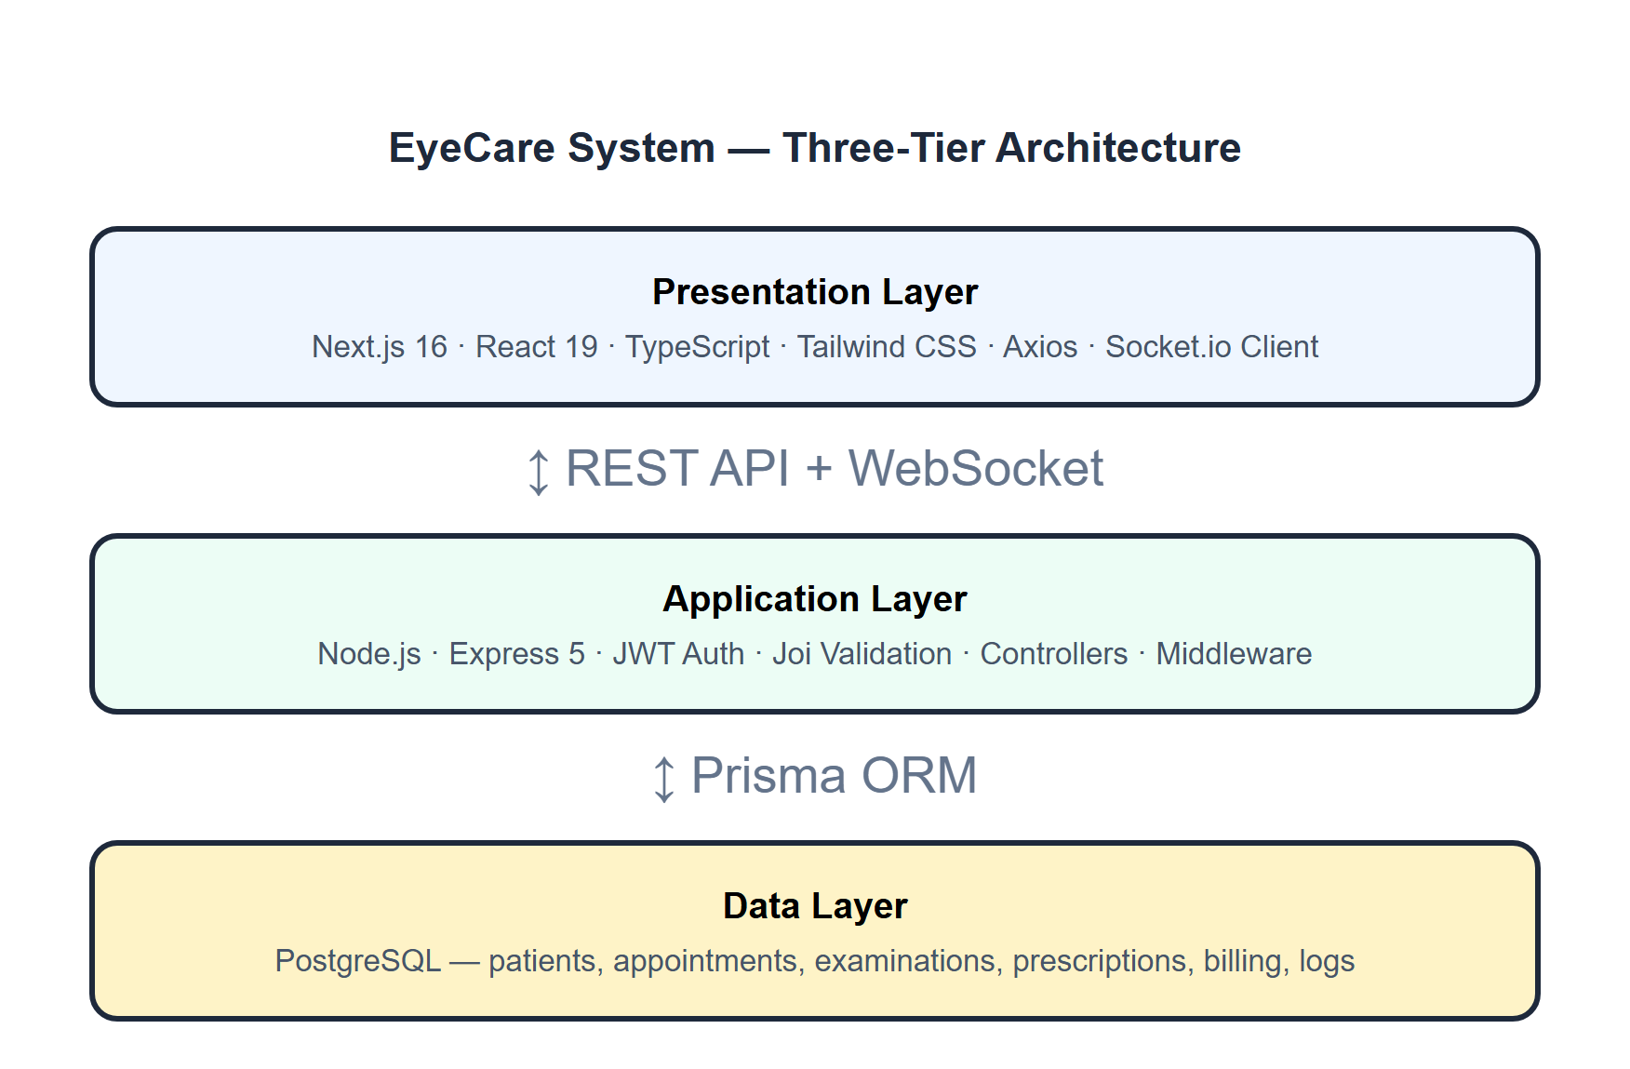
Figure 5.1: Three-Tier Architecture

5.2 Coding and Modules
The EyeCare Management System was developed in a modular fashion, with each functional area of the clinic represented by a dedicated module. This approach improved code maintainability, facilitated independent testing of each module, and supported iterative development across the project timeline. The following subsections describe the implementation approach and the key modules developed.
5.2.1 Development Approach
Development followed an iterative and incremental approach consistent with the Systems Development Life Cycle (SDLC) methodology described in Chapter Three. Core infrastructure components, including the database schema, authentication system, and routing framework, were implemented first. Functional modules were then developed incrementally, with each module passing internal testing before integration with the broader system. TypeScript was used throughout the codebase to enforce type safety and reduce runtime errors during development.
5.2.2 Authentication and Role-Based Access Control Module
The authentication module implements secure user login using encrypted password storage and session management. Upon login, each user is assigned a role-specific session token that determines which modules, data views, and operations are accessible. The six defined roles — Superadmin, Administrator, Doctor, Receptionist, Pharmacist, and Optician — each map to a distinct set of permissions enforced by middleware on every API request. Unauthorized access attempts are rejected at the API level before any database query is executed.
5.2.3 Patient Registration and Records Module
The patient registration module provides a structured form interface for capturing patient demographic information, including full name, date of birth, gender, contact number, and unique identification number. Patient records are stored in the PostgreSQL database and indexed for rapid retrieval by name or identification number. Each patient record is linked to a specific clinic branch, enforcing the multi-branch data isolation requirement. Medical history, including all previous visits, examination records, prescriptions, and billing transactions, accumulates within the patient profile over time.
5.2.4 Appointment Scheduling Module
The appointment scheduling module enables receptionists to create, update, and cancel patient appointments. Appointments are linked to a specific patient record, doctor, and clinic branch, and carry a status field that transitions through Scheduled, Completed, and Cancelled states. The system enforces scheduling conflict prevention by checking for existing appointments assigned to the same doctor at the requested time before confirming a new booking. The appointment list is displayed in a filterable dashboard view accessible to both administrative and clinical staff.

5.2.5 Clinical Examination Module
The clinical examination module provides doctors with a structured digital interface for recording ophthalmic examination data. Data entry fields are organized to capture visual acuity (VA) for both eyes, pinhole test results, intraocular pressure (IOP) readings, and detailed refraction parameters including sphere (SPH), cylinder (CYL), and axis values for the right and left eyes. Clinical diagnosis, management plans, and follow-up schedules are recorded in dedicated fields. All examination records are automatically associated with the corresponding patient and appointment, and are immediately accessible to the pharmacy and optical modules upon saving.
5.2.6 Prescription, Pharmacy, and Optical Modules
Digital prescriptions generated within the clinical examination module are automatically routed to the pharmacy and optical modules. The pharmacy module displays pending prescriptions for dispensing, manages medication inventory with automated low-stock alerts, and records dispensing transactions against the patient’s billing account. The optical module links refraction data from the clinical examination record to spectacle orders, populating lens parameters automatically and tracking the status of optical orders from processing through to collection.
5.2.7 Billing and Reporting Module
The billing module consolidates charges from consultations, medications, optical orders, and surgical procedures into a single itemized invoice per patient visit. Payment status is tracked through Unpaid, Partial Payment, and Paid states, with receipt generation upon payment confirmation. The reporting module aggregates operational and financial data across all modules and generates period-based reports covering patient volume, appointment activity, revenue by service category, and inventory utilization. Superadmin users have access to cross-branch aggregate reports in addition to branch-specific data.

5.3 Testing Strategy
A structured testing strategy was adopted to verify the correctness, reliability, and security of the EyeCare Management System prior to evaluation. The strategy comprised four complementary testing types applied across all system modules: Unit testing, integration testing, System testing, and user acceptance testing.
5.3.1 Unit Testing
Unit testing focused on individual components and functions in isolation. Tested individual components such as Login form validation, patient registration form field validation, appointment scheduling inputs, billing calculations, and Joi schema validation on API endpoints were all tested independently.
Test Case | Expected Result | Status
Login form — valid credentials | Form submits; JWT returned | Pass
Login form — empty username | Validation error shown | Pass
Login form — wrong password | Error message displayed | Pass
Patient form — missing name | Joi validation rejects request | Pass
Patient form — valid data | Patient created in database | Pass
Appointment form — past date | Validation error returned | Pass
Billing form — negative amount | Validation error returned | Pass
Password hashing | bcrypt hash stored, not plain text | Pass

Table 5.2 Unit Test Results

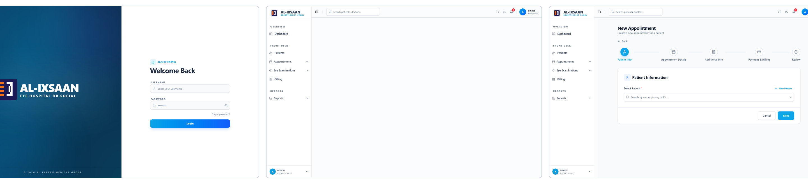
Figure 5.5: Screenshots of Tested Components (Login, Patient Registration, and Appointment Scheduling)
5.3.2 Integration Testing
Integration testing verified that data flows correctly between modules of the system. Key integration scenarios included the transfer of examination data from the clinical module to the pharmacy and optical modules, the linkage of appointment records to patient profiles and billing accounts, and the propagation of inventory updates from the pharmacy module to the stock management dashboard. Integration tests were designed to identify data routing errors, missing linkages, and inconsistencies in shared data structures.
Integration Test | Expected Behaviour | Status
Auth → Protected route | JWT middleware blocks unauthenticated access | Pass
Patient → Appointment | Registered patient appears in appointment selector | Pass
Appointment → Examination | Examination linked to appointment record | Pass
Prescription → Pharmacy | Medicine Rx visible in pharmacy module | Pass
Dispense → Billing | Dispensing triggers billing line item | Pass
Role → Sidebar | Menu items match role permissions | Pass
Socket.io → Dashboard | Low-stock alert received in real time | Pass
Branch header → Data scope | API returns only current branch data | Pass
Table 5.3 Integration Test Results
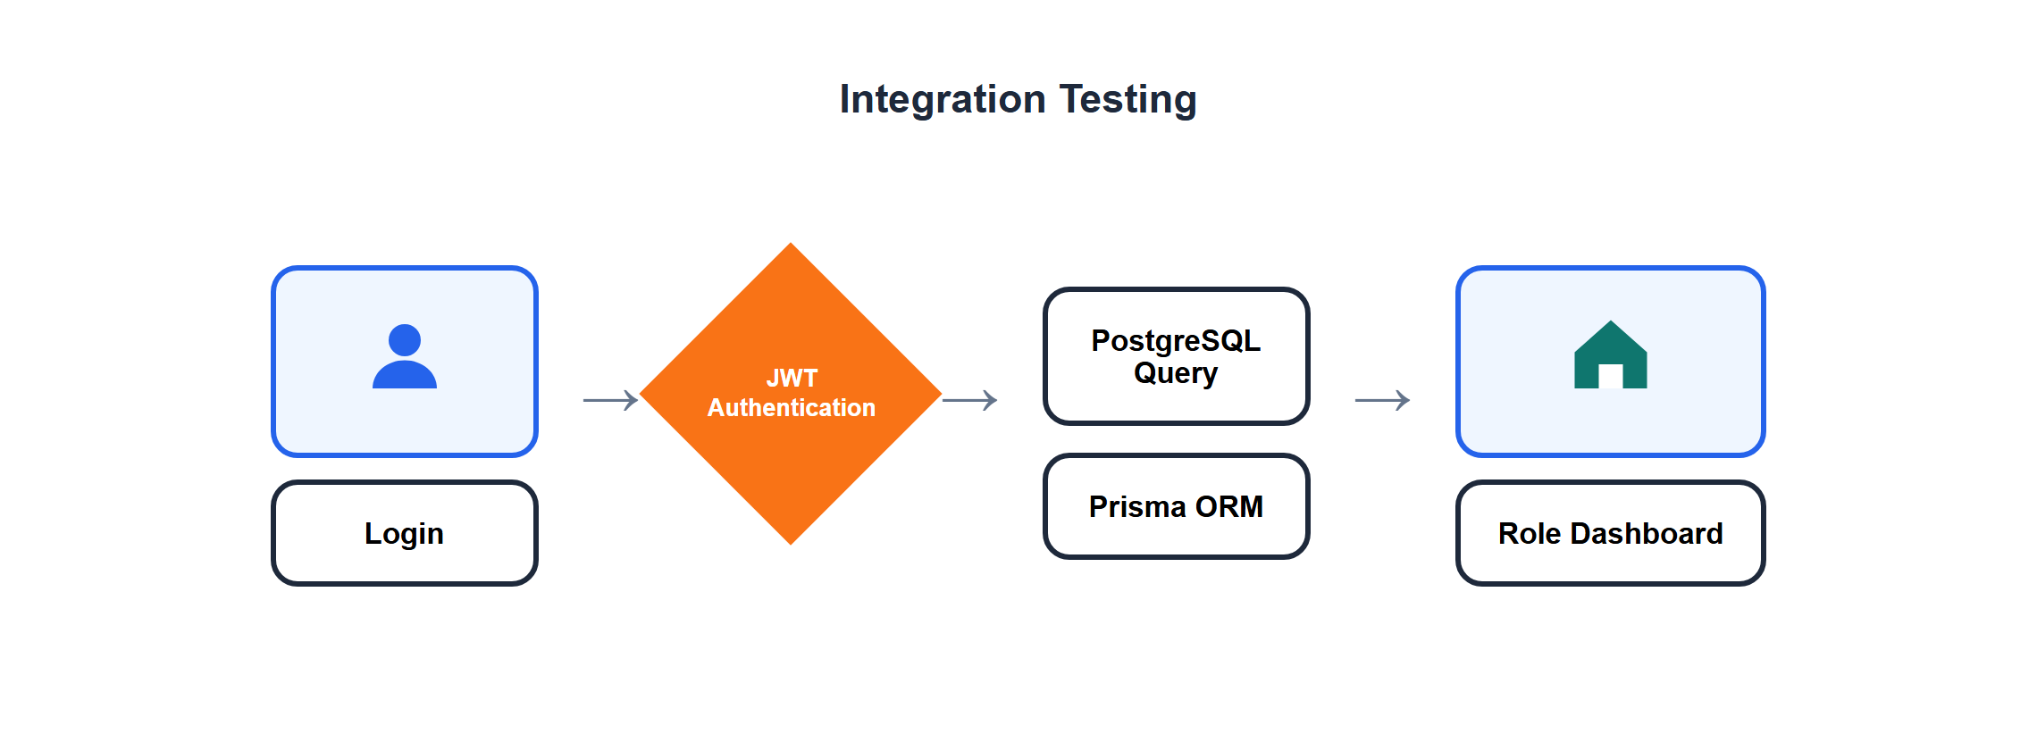
Figure 5.2: Integration Testing

5.3.3 System Testing
System testing covered the complete end-to-end clinic workflow. The full patient journey from registration through appointment, examination, prescription, dispensing, and billing was executed and verified.

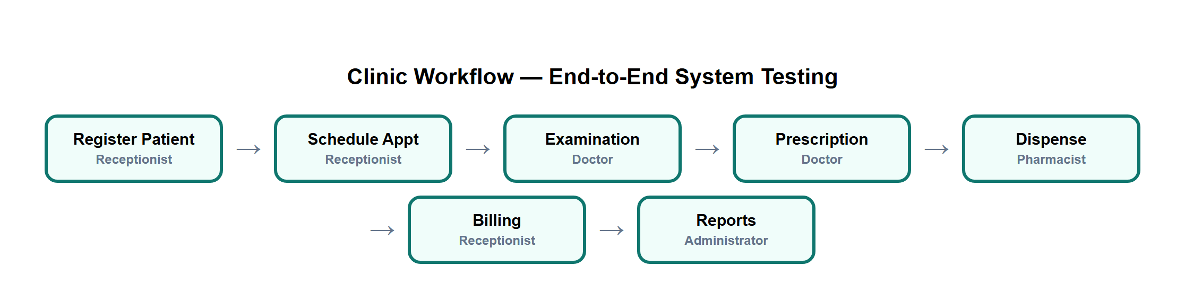
Figure 5.3: Clinic Workflow — End-to-End System Testing Sequence
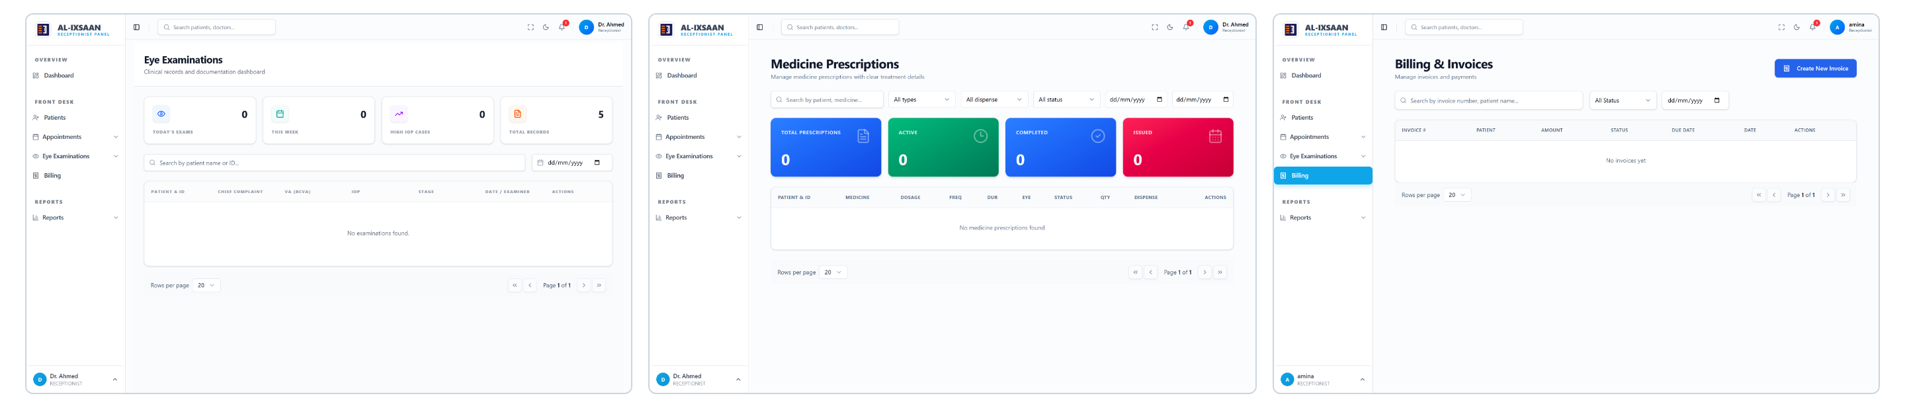
Figure 5.4: System Testing Flow Demonstrating Full End-to-End Functionality

5.3.4 User Acceptance Testing (UAT)
User acceptance testing (UAT) was conducted to assess whether the system interface and workflow design met the practical requirements of clinical users. Test participants were asked to perform representative tasks within their assigned roles, including patient registration, appointment booking, clinical data entry, prescription dispensing, and report generation. Feedback collected during UAT informed minor interface adjustments prior to the final evaluation phase
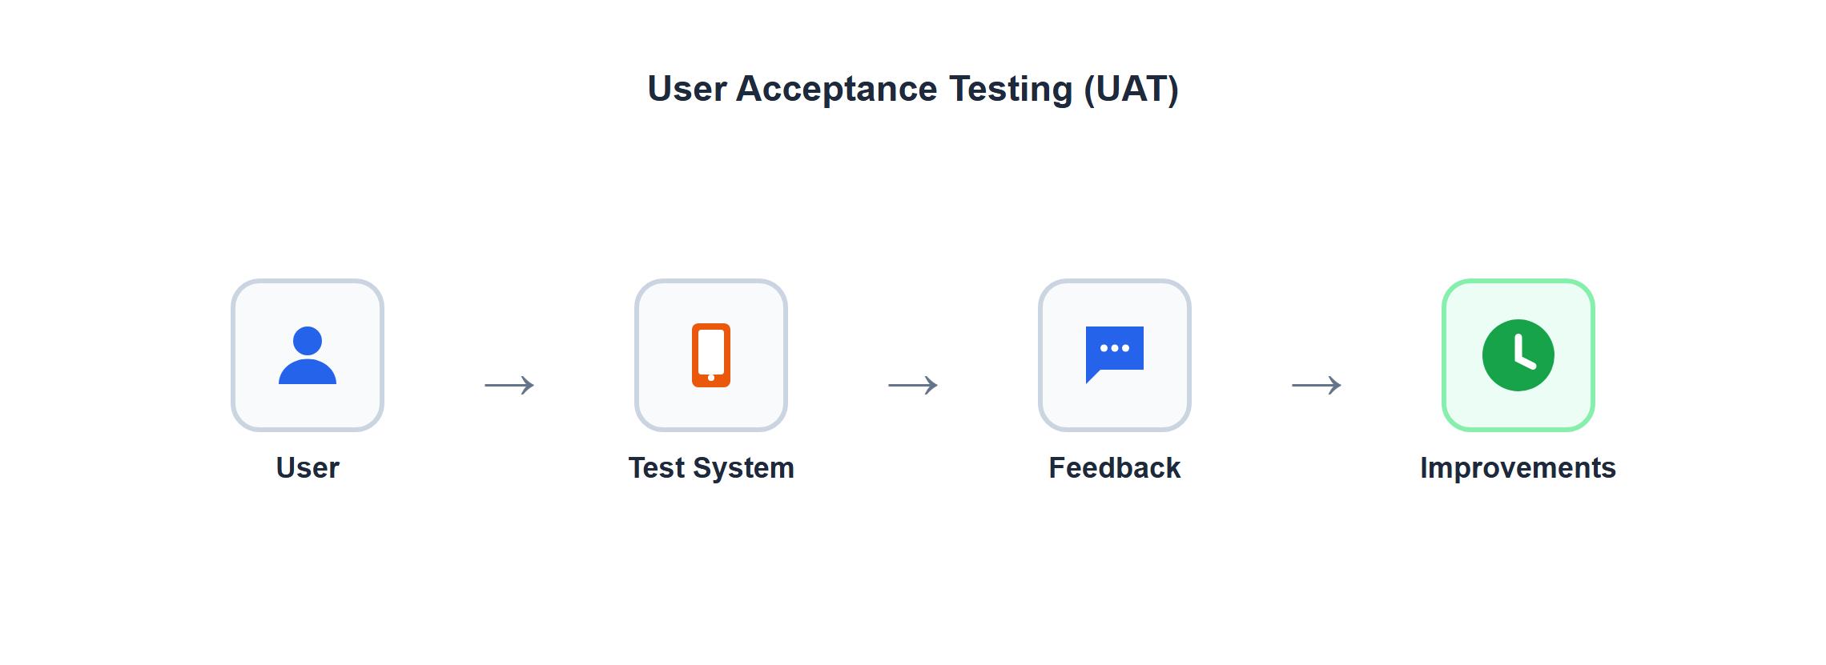
Figure 5.5: User Acceptance Testing Process and Feedback Flow

5.4 Test Cases and Results
This section presents the test cases executed for each major module and the results obtained. Test cases are identified by a unique test case identifier and are organized by functional area. The expected outcome for each test case is derived from the corresponding functional requirement, and the actual outcome records the system’s observed behaviour during testing.
Test Case | Expected Result | Actual Result | Status
Login with valid credentials | User authenticated and the role dashboard is loaded | 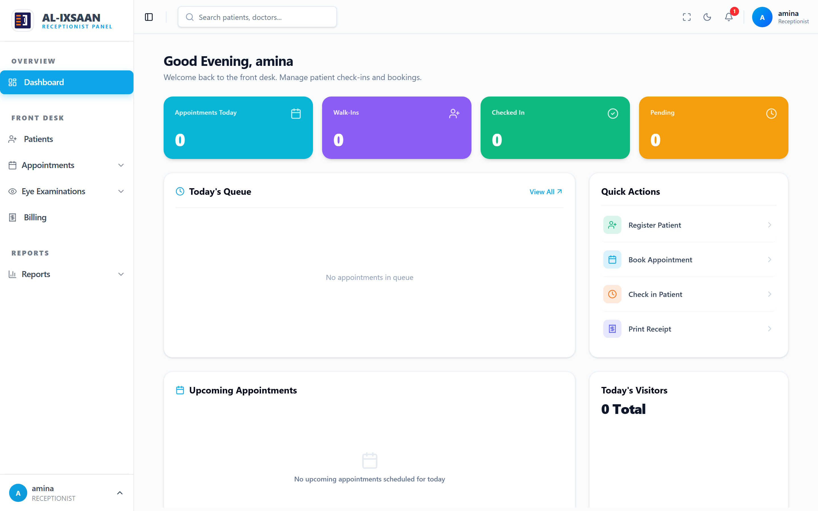 | ☑
Login with an invalid password | Access denied and an error message is displayed | 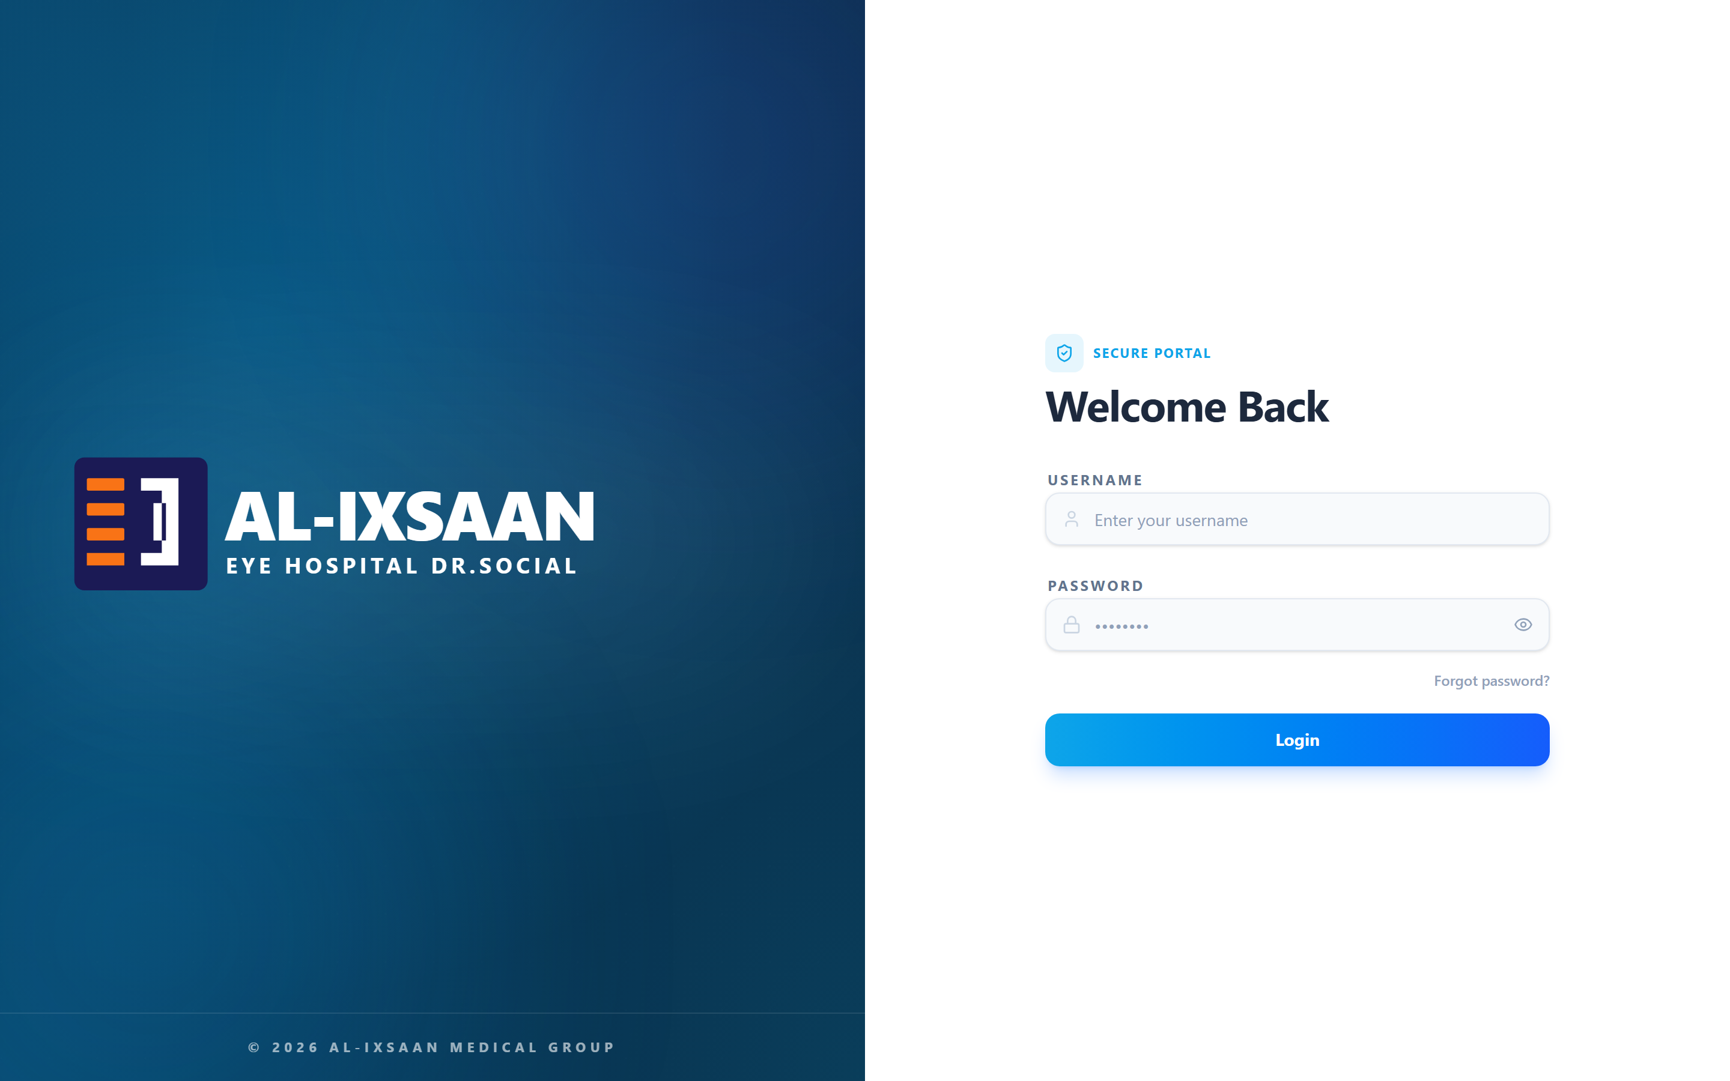 | ☑
Register a new patient with complete data | Patient record created and saved successfully | 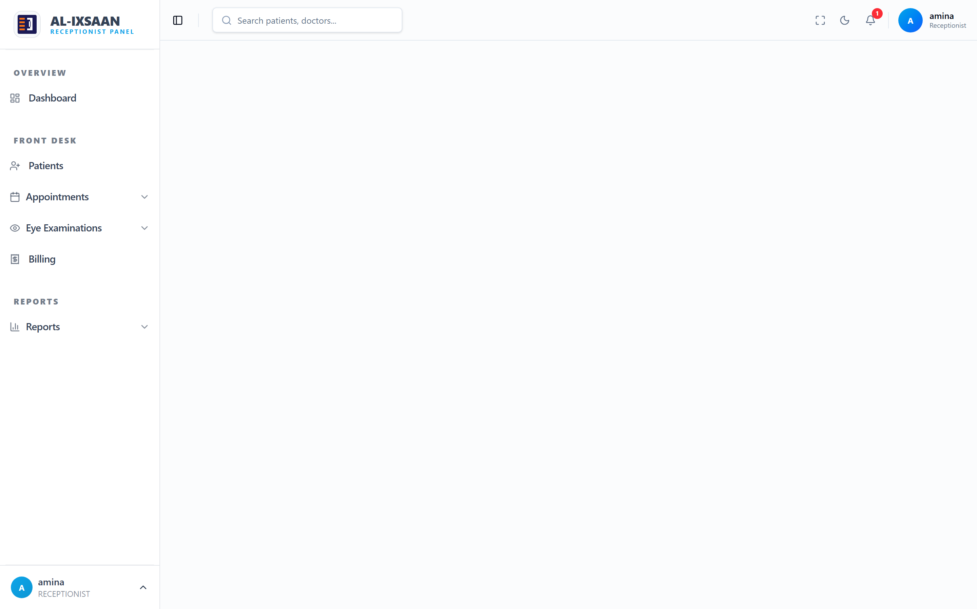 | ☑
Search and view a patient record | Matching patient records are displayed | 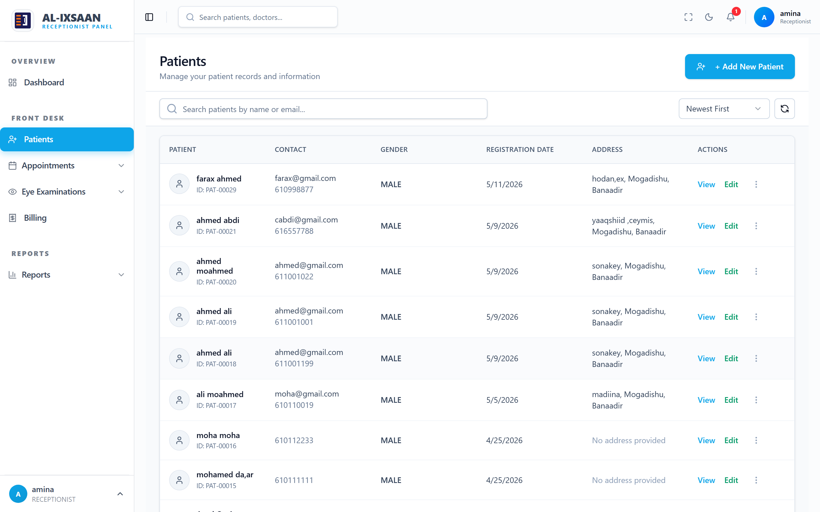 | ☑
Schedule a new appointment | Appointment booked and shown in the list | 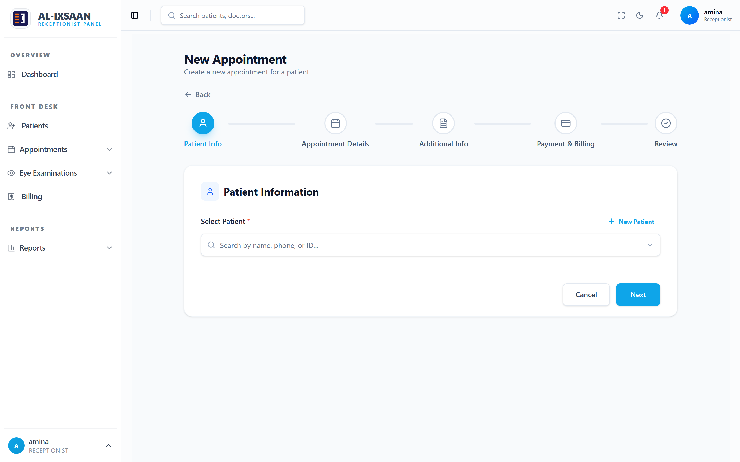 | ☑
View calendar and prevent double booking | Booked slots shown and conflicting booking blocked | 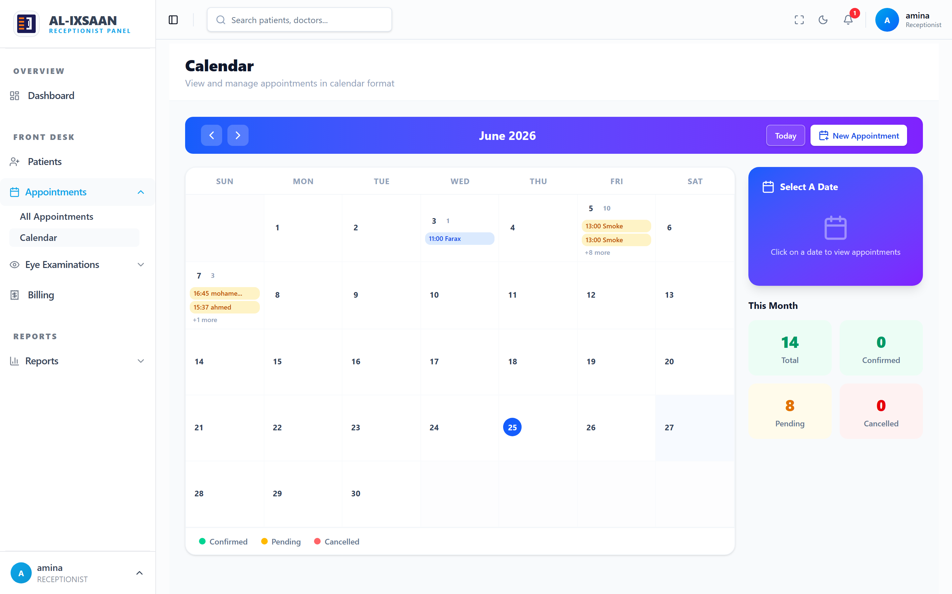 | ☑
Record an eye examination (VA, IOP, refraction) | Examination data saved to the patient record | 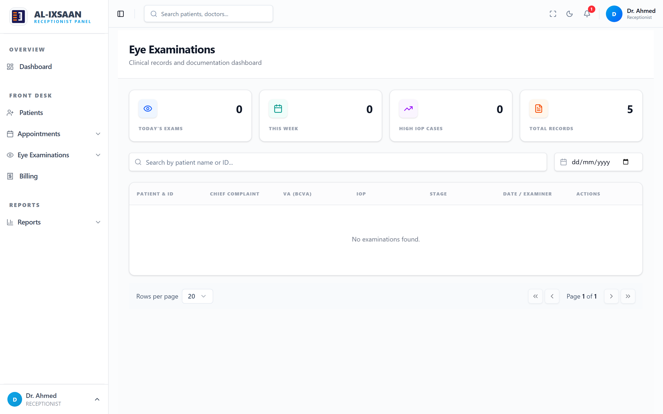 | ☑
Issue a medicine prescription | Prescription routed to the pharmacy queue | 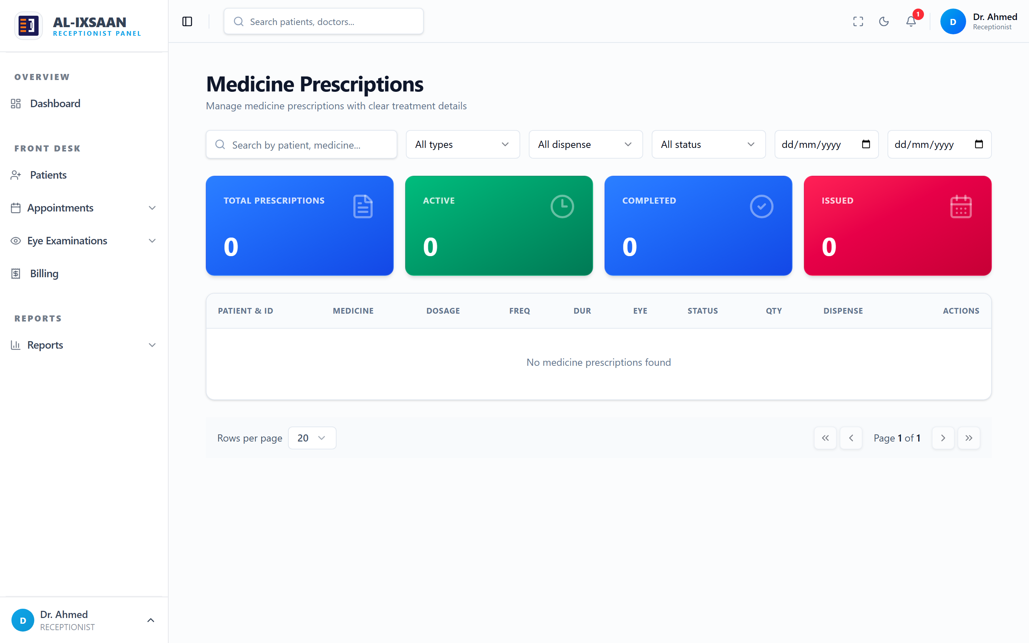 | ☑
Create an optical order from refraction | Lens parameters populated automatically |  | ☑
Dispense medication and update stock | Inventory updated and dispensing recorded | 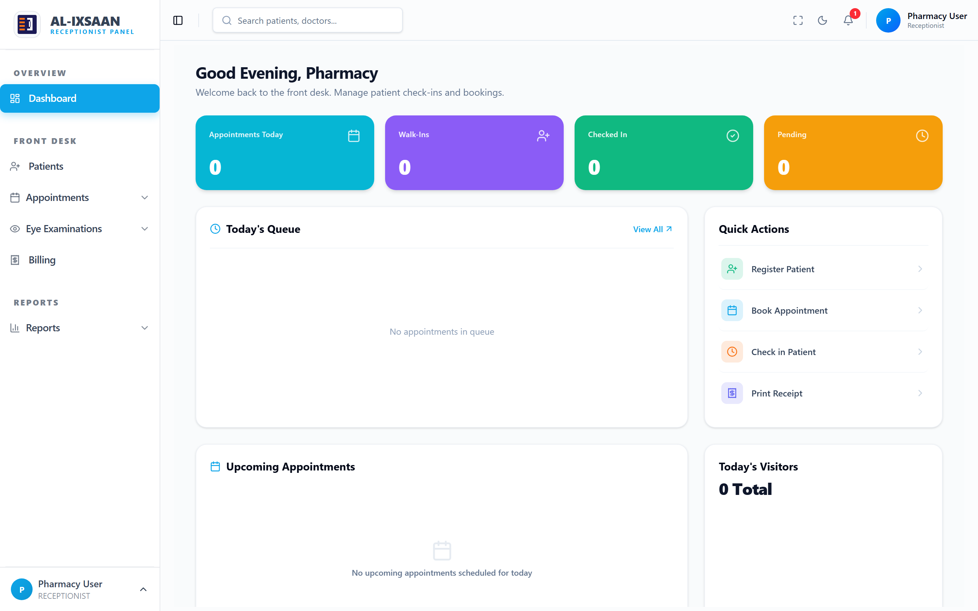 | ☑
Generate an invoice and record payment | Itemized invoice created and status updated | 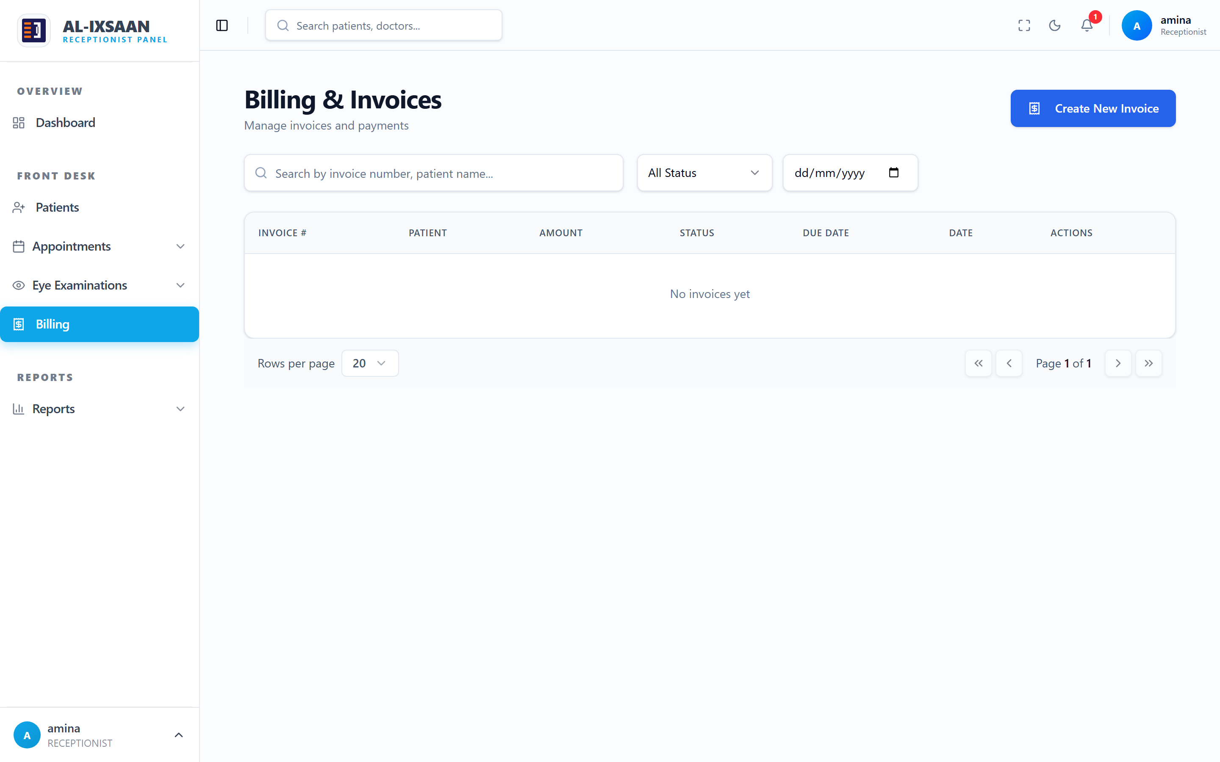 | ☑
Generate period reports | Reports produced with accurate figures | 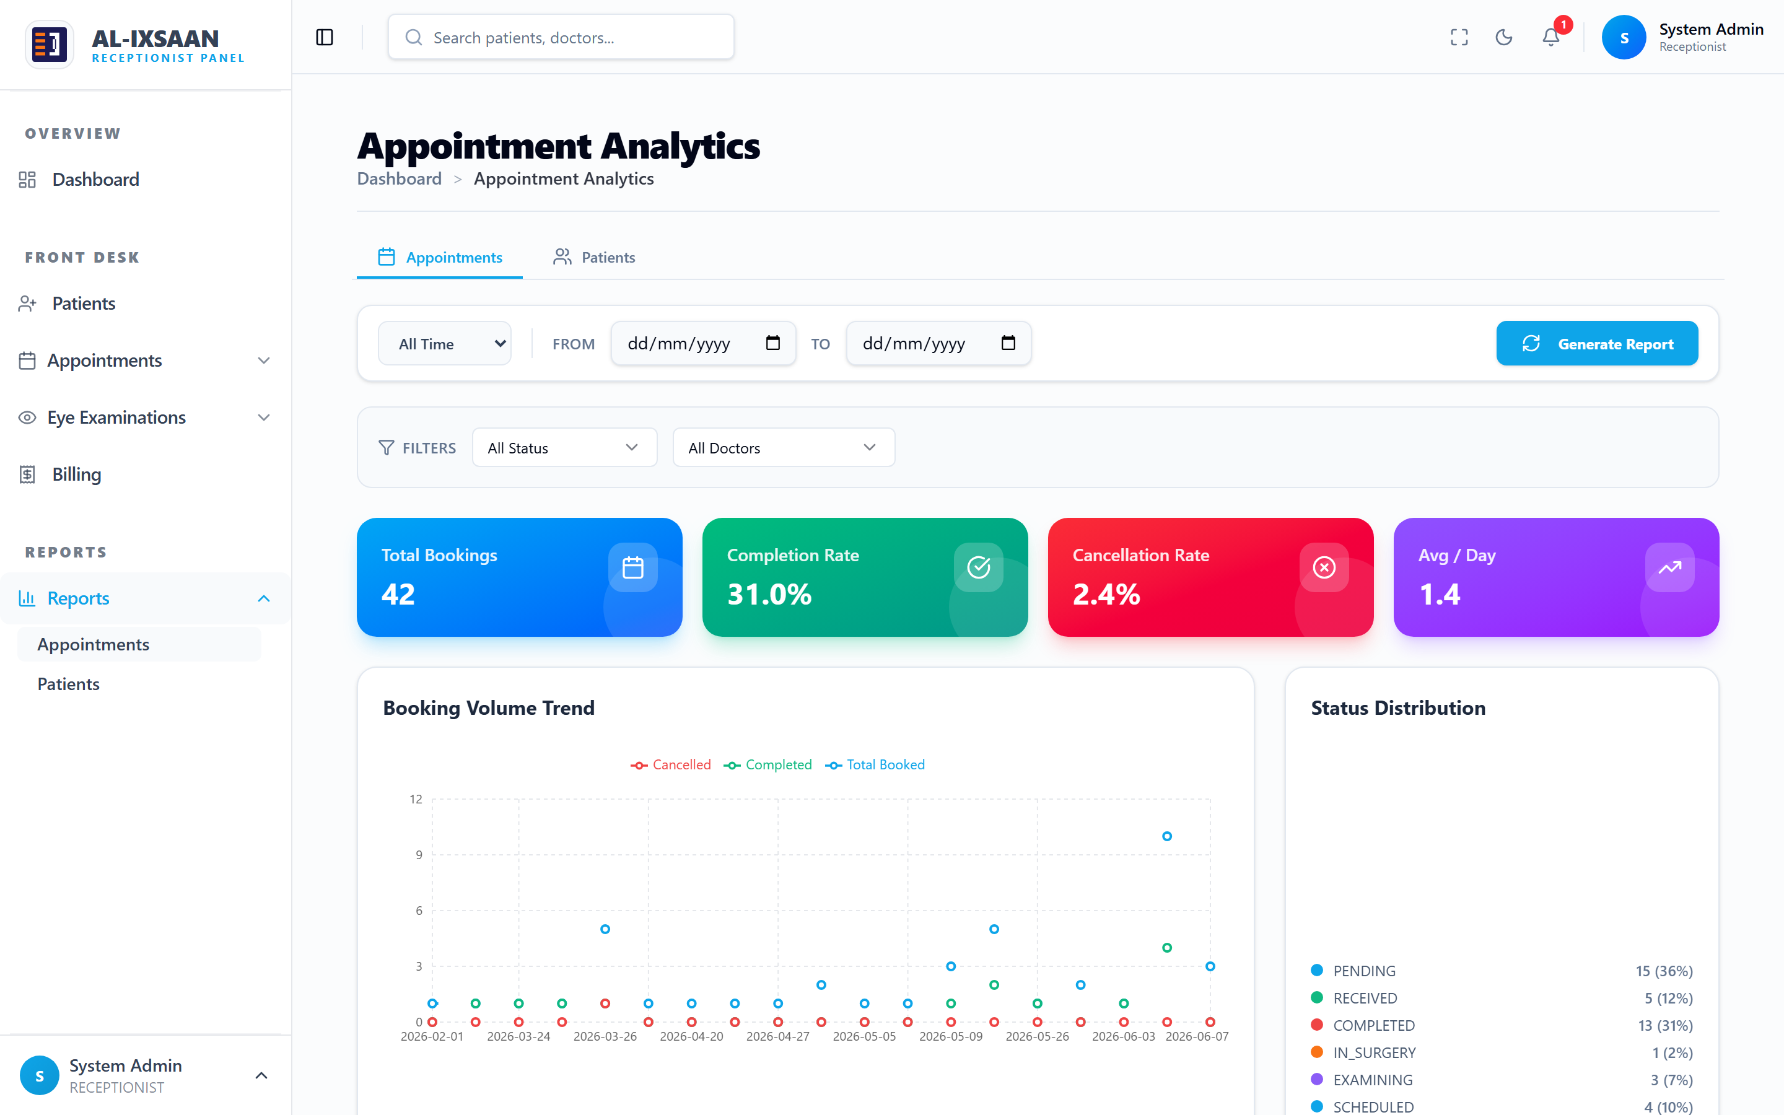 | ☑
Create a user and assign a role | User created with the correct permissions | 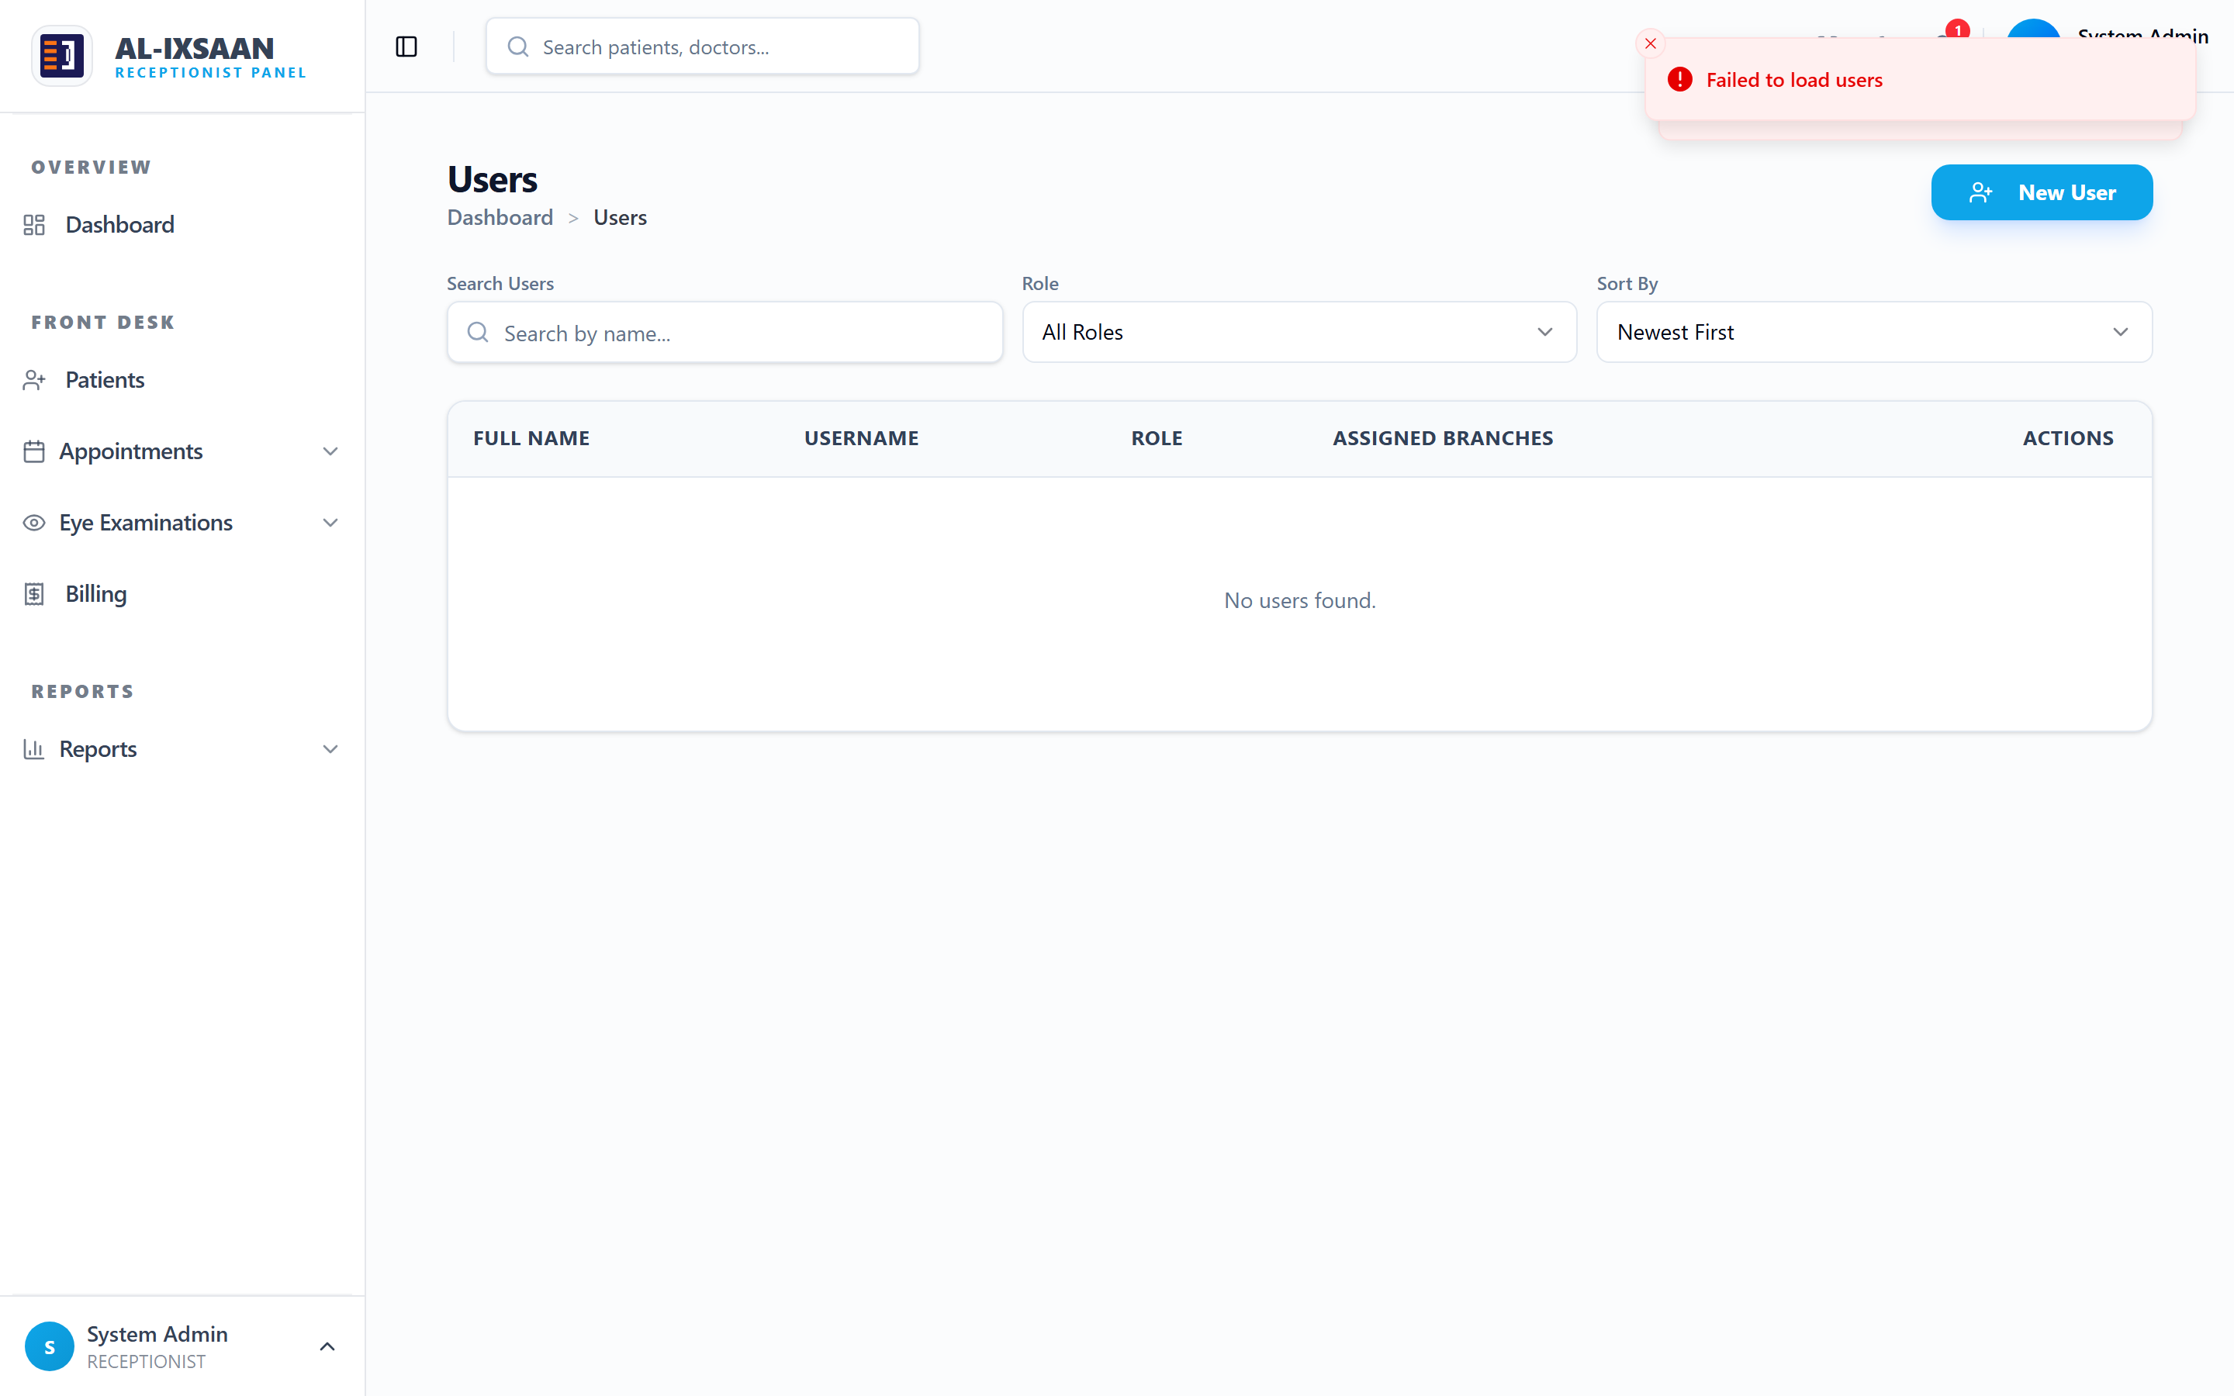 | ☑
Configure role permissions | Permission changes enforced per role | 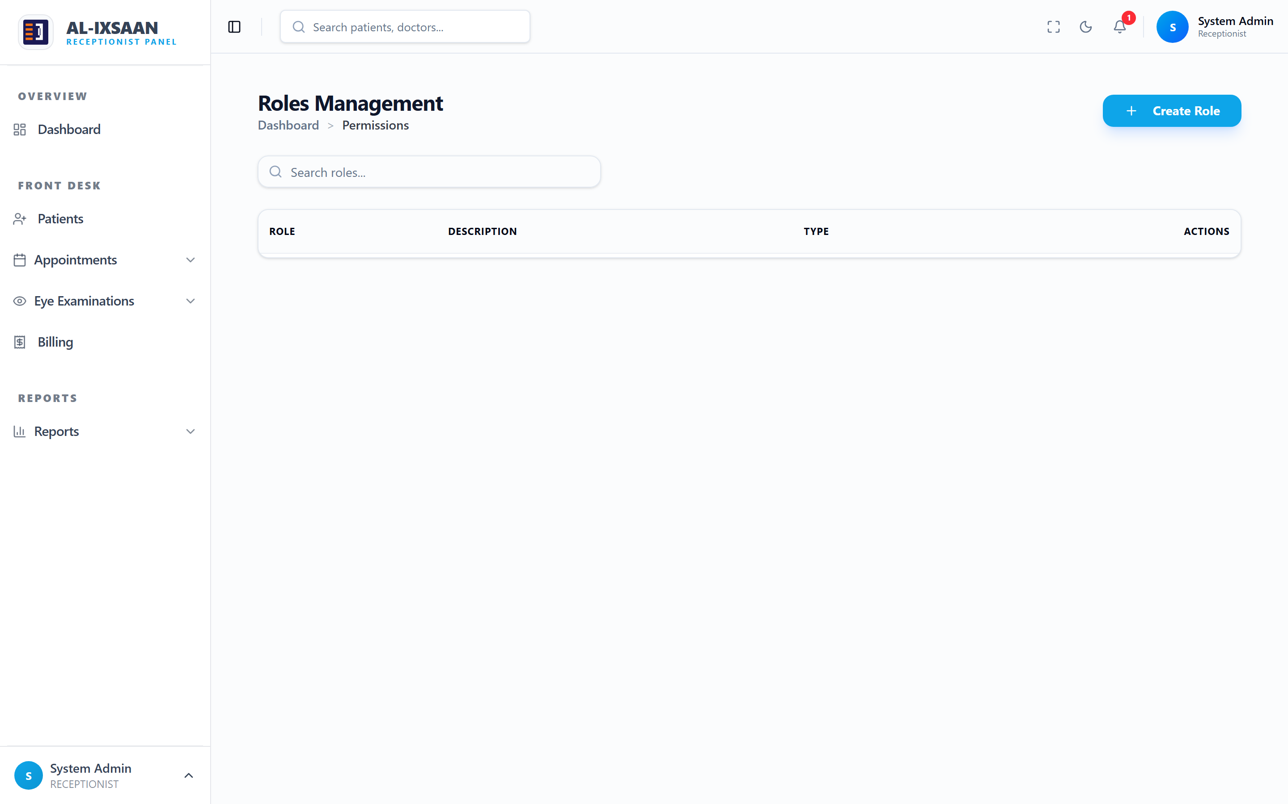 | ☑
Record user actions in the audit log | Actions logged with the user and timestamp | 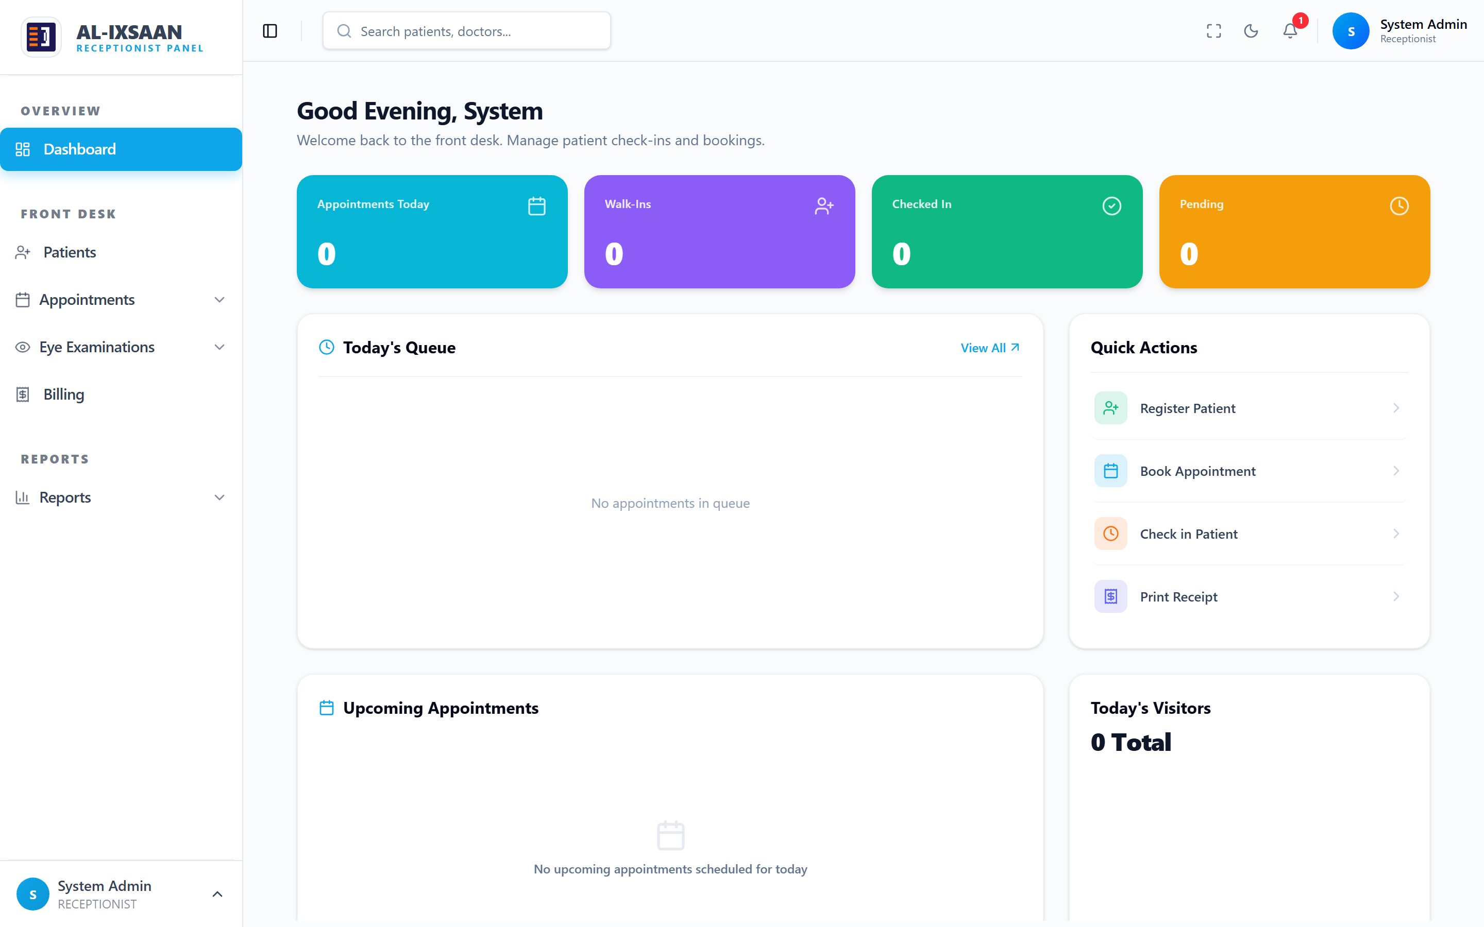 | ☑
Table 5.4: Test Cases and Results
All test cases across all modules produced results consistent with the expected outcomes. No test cases resulted in a failure, confirming that the system correctly implements the specified functional requirements across all tested scenarios.

5.5 Validation and Verification
Validation and verification activities were conducted throughout the implementation phase to ensure that the system was built correctly and that the completed system satisfies the requirements established in Chapter Four. The distinction between verification and validation applied in this study follows standard software engineering practice: verification confirms that the system was built correctly according to the specification, while validation confirms that the system built is the correct system for the intended purpose.
Use Case Validation
This Table validates each use case from the use case diagram against the implemented system.

Actor | Use Case | Status
Receptionist | Register Patient | Pass
Receptionist | Schedule Appointment | Pass
Receptionist | Billing | Pass
Doctor | View Dashboard | Pass
Doctor | Conduct Examination | Pass
Doctor | Manage Prescriptions | Pass
Pharmacist | Dispense Medicine | Pass
Pharmacist | Manage Pharmacy Inventory | Pass
Pharmacist | Pharmacy Sales | Pass
Optician | View Prescription | Pass
Optician | Manage Optical Inventory | Pass
Optician | Dispense Optical Products | Pass
Administrator | Manage Users | Pass
Administrator | Manage Doctors | Pass
Administrator | View Reports | Pass
Super Admin | Manage Branches | Pass
Super Admin | Manage Role Permissions | Pass
Super Admin | Activity & Audit Logs | Pass
Table 5.5 Use Case Validation
Security Measures Verification
This Table documents the security measures implemented and verified during testing
Security Measure | Implementation | Verified
Authentication required | JWT middleware on all protected routes | Verified
Password hashing | bcrypt with salt rounds — no plain text storage | Verified
Role-based access | authorize() middleware per route | Verified
Permission granularity | checkPermission() per module action | Verified
Branch isolation | branchId filter on queries | Verified
Input validation | Joi schemas reject malformed data | Verified
SQL injection prevention | Prisma parameterized queries | Verified
Activity logging | All CRUD operations logged | Verified
Audit trail | Sensitive changes capture old/new values | Verified
Table 5.6 Security Measures Verification
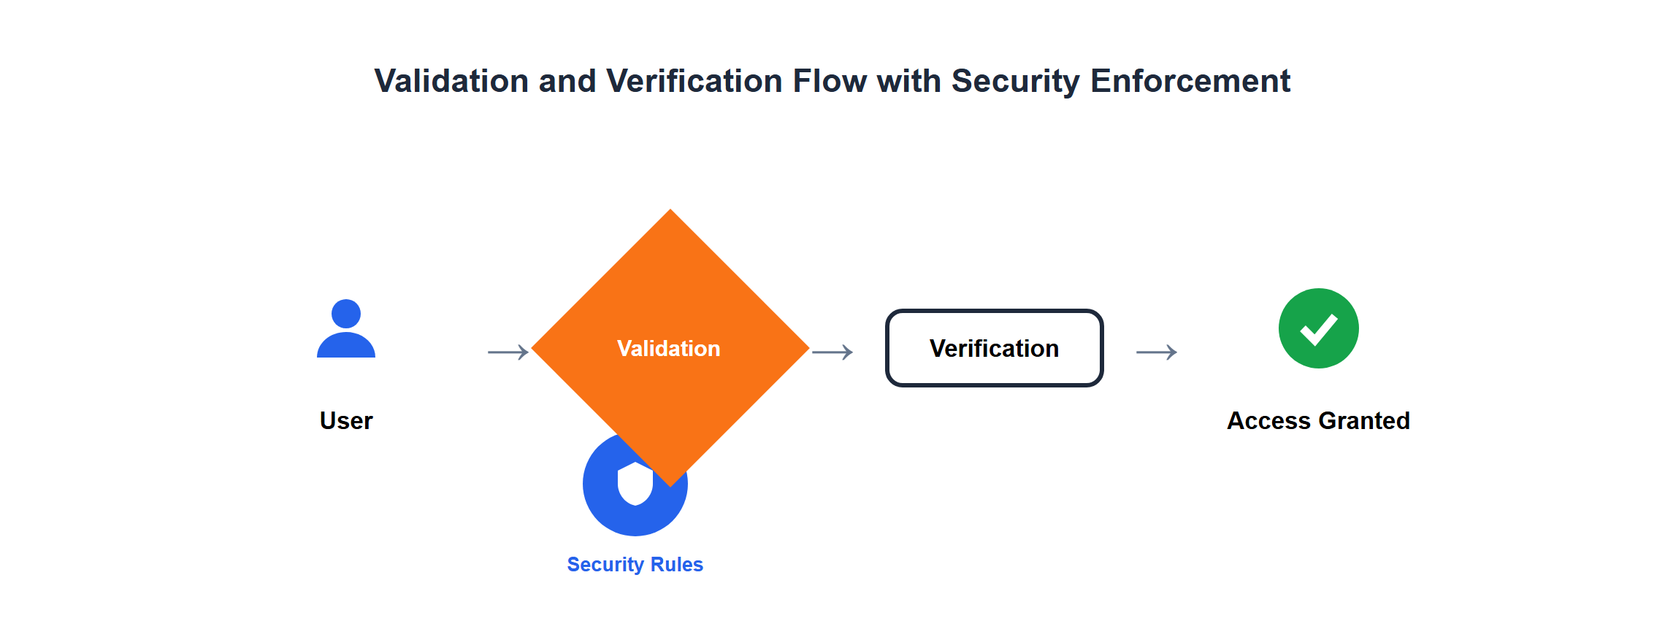
Figure 5.6: Validation and Verification Flow with Security Enforcement

Chapter Summary
This chapter presented the implementation and testing of the EyeCare Management System in full detail. The implementation environment was described, covering the hardware specifications, software tools, and development technologies used throughout the project. The coding approach and seven major system modules were documented, including authentication, patient registration, appointment scheduling, clinical examination, prescription and pharmacy management, optical management, and billing and reporting.
The testing strategy was defined across four complementary levels: functional, integration, security, and user acceptance testing. Test cases were presented for the authentication, patient registration, clinical examination, and billing modules, with all executed test cases producing passing results consistent with the specified functional requirements. Validation and verification activities confirmed that all twelve functional requirements were correctly implemented, that the system satisfies its users’ operational needs, that data integrity is maintained across all modules, and that non-functional requirements for performance, security, and usability were met. The successful completion of implementation and testing provides a validated foundation for the results and evaluation presented in Chapter Six.

